HBL Power Systems Ltd, India | Technical Description for  relay interface box for Vande Bharat

TECHNICAL DESCRIPTION
FOR
Relay interface box (RIB) for vande bharat

Document Number: 5 16 27 0054
Version: 1.0

Date Published: 20-12-2022

Prepared By
HBL Power Systems Limited
Hyderabad

This document and its content are the property of HBL Power Systems Ltd, who alone reserves the right for distribution use and reproduction

DOCUMENT DATA SHEET

Title of Document | File Name | Pages | Figures | Tables
Technical Description for Relay Interface Box for Vande Bharat | Technical Description for Relay Interface Box for Vande Bharat | 19 | 2 | -

Prepared by | Reviewed by | Approved by
D Lovaraju  (Engineer) | JVV Prasad  ( Dy. Manager) | Y. Subrahmanyam  (Head -Engineering)

Abstract
This document describes the features and functions of the Relay Interface Box for Vande Bharat and explains the design of the same.

DOCUMENT CONTROL SHEET
# | Name | Organization | Function | Level
1 | D Lova Raju | HBL | Engineering | Prepare
2 | JVV Prasad | HBL | Engineering | Verify
3 | Y. Subrahmanyam | HBL | Engineering | Approve

CHANGE HISTORY

# | Date | Reason for changes | Updated by | Version
1 | 20-12-2022 | Initial | D Lovaraju | 1.0

GLOSSARY OF TERMS
# | Abbreviation | Meaning
 | BC | Brake Cylinder
 | BP | Brake Pipe
 | MR | Main Reservoir
 | CAN | Controller area network
 | LP-OCIP | Loco Pilot Operation Cum Indication Panel
 | EB | Emergency Brake
 | FR | Functional Requirement
 | FSB | Full-Service Brake
 | LV | Limiting Valve
 | VEB | Vital Emergency Brake
 | SR | Safety Requirement
 | KAVACH(TCAS) | Train Collision Avoidance System
 | VB RIB | Relay Interface Box
 | EP | Electro Pneumatic
 | ATP | Automatic Train Protection
 | BIC | Brake Interface Card
 | DC | Direct Current
 | VEB | Vital Emergency Brake
 | VB | Vande Bharat
 | RIB | Relay Interface Box
 | TCMS | Train Control Monitoring System

Table of Contents
1.0 SCOPE 8
2.0 PURPOSE 8
3.0 VB RIB FUNCTIONAL & SAFETY REQUIREMENTS 8
4.0 BRAKE APPLICATION ON LOCOMOTIVES 11
5.0 VB RIB DESIGN DESCRIPTION 12
6.0 VB RIB – Electrical Circuit 13
7.0 Electronics in VB RIB 14
7.1 Brake interface card (BIC) 14
7.2 BIC power supply card 15
8.0 COMPLIANCE WITH SAFETY REQUIREMENTS 15
8.1 Fail Safety 15
8.2 Health Monitoring 15
8.3 Isolation 16
9.0 Dimensional details of VB RIB 16
9.1 Without mounting arrangement 17
10.0 Technical Specification Sheets 17
11.0 Schematic diagram of KAVACH interface with Vande Bharat braking system 18
12.0 Block Diagram of Relay Interface Box for Vande Bharat Locomotive. 19

- SCOPE
  - This document relates to the design of VB Relay Interface Box (VB VB RIB) for use on Vande Barath locomotives and ATP systems like KAVACH.

- PURPOSE
  - KAVACH is designed to ensure safe train operation in the event of human failure by stopping or controlling the speed of trains.
  - For the sake of brevity, KAVACH will hereafter be referred to as ATP system.
  - It is necessary for Automatic Train Protection (ATP) systems to be interfaced with the braking system of the locomotive for parallel braking application.
  - Under certain circumstances, it is also necessary to isolate the ATP braking and allow the Loco Pilot to operate the locomotive manually.
  - The purpose of this document is to propose the design of VB RIB for ATP system that fulfills the above safety requirements.

- VB RIB FUNCTIONAL & SAFETY REQUIREMENTS

  - The functional requirements of VB RIB are listed below.
# | Requirements
FR-1 | VB RIB shall work in parallel to the existing locomotives braking system (controlled by the Pilot)
FR-2 | VB RIB shall not modify the existing braking characteristics of the locomotives
FR-3 | The VB RIB shall have provision for executing following brake commands  a) Full Service Brake (FSB) command  FSB –BP Pressure Drop to 3.5 kg/cm2 from 5.0 kg/cm2  b) Emergency Brake (EB) command  EB – BP Pressure Drop to 0 kg/cm2 from 5.0 kg/cm2
FR-4 | Based on the input signal received from the ATP system through VB RIB, the existing brake control system shall apply the corresponding brake, as mentioned at FR-3 above.
FR-5 | Separate Relays shall be used for following brake applications  - Full-Service Brake  - Emergency brake  - QRV
FR-6 | On withdrawal of brake command from ATP system, the corresponding brake shall be released, and restoration of traction control shall be enabled.
FR-7 | There shall be a facility to override the "ATP system initiated braking" by the "driver’s braking" (or vice-versa) to achieve higher braking intensity whenever required). Loco Pilot can override and increase braking effort generated by VB RIB, but not decrease the same. Also, the lower braking intensity of ATP shall be overridden by a higher braking intensity produced by other train safety systems, if any. Arrangement for data logging for the above scenario shall be available.
FR-8 | VB RIB shall be capable of receiving braking command simultaneously from the Loco pilot through Brake Controller handle as well as from the ATP system at the same time. In case of multiple braking requests received simultaneously, the VB RIB should implement the command demanding for the highest braking effort.
FR-9 | VB RIB shall have provision to obtain feedback from existing system about the execution of braking command given to it by ATP system and communicate it back to ATP system.
FR-10 | VB RIB shall have a provision of point to point communication with ATP system.
FR-11 | The communication between the VB RIB and the ATP system shall be on RS485. RS485 communication ports should have galvanic/optical isolation.
FR-12 | There shall be provision for Isolation of the complete VB RIB. Isolation shall be provided in case of malfunction. After isolation, the normal brake characteristics of the locomotive brake system shall not be affected.
FR-13 | The VB RIB shall have the facility to isolate itself from the loco pneumatic system through an isolation cock. The isolation shall be achieved through valve electrically operated by the VB RIB.
FR-14 | The Brake unit isolation shall be monitored and its status shall be communicated by VB RIB to ATP system.
FR-15 | The VB RIB shall have a non- re-settable counter to register the instances of brake unit getting isolated by the Loco Pilot.
FR-16 | The VB RIB isolation switch shall be located on the VB RIB such that it is accessible for operation by the Loco Pilot.
FR-17 | There shall be a provision of manual isolation of the VB RIB. Pneumatic inlet pipe BP to VB RIB shall be provided with isolating cock to the unit.
FR-18 | VB RIB shall have a Self-Test feature for the detection of failed valves/relays/sensors by performing self-diagnosis at power ON and give alerts to a user through ATP system display. The VB RIB shall have the facility to communicate its diagnostics information to ATP system.
FR-19 | VB RIB shall have provision for redundant control for emergency brake command, which shall be activated if the default control mechanism fails
FR-20 | For any internal failure in VB RIB, the following action shall be taken by VB RIB.  - Brakes will be applied.  - System goes to failure mode.
FR-21 | All supply voltages for operating the VB RIB shall be generated from loco battery which shall be in the range 78V to 136V DC

  - Requirements for data logging of braking events generated by equipment connected to communication ports (For ATP system).

# | Requirement
FR-22 | Recording of VB RIB isolation event with date and time and number of counts of VB RIB isolation.
FR-23 | Arrangement for data logging for the braking event shall be available with ATP. The status of following events shall be logged at 1-sec interval/change in events, with date and time stamp  - ATP brake command active  - Isolation of VB RIB  - VB RIB failure log  - Relays/valves failure log  - VB RIB brake command override by Loco pilot brake command, vice versa  - Any change in BP/BC greater than 0.3Kg/cm² to be logged
FR-24 | The facility for the storage of data log shall be for 90 days. An application running on PC shall be provided for downloading the Log and evaluating the same.

  - The safety requirements of VB RIB are listed in the following table.

# | Requirements
SR-1 | The emergency brake command shall be fail-safe.
SR-2 | In case of power supply failure to VB RIB, the emergency brake shall get activated.
SR-3 | In case of communication failure between VB RIB and ATP System, the VB RIB shall command emergency brake.
SR-4 | In case of critical failure of VB RIB electronics interfaced with ATP System, emergency brakes shall get activated.
SR-5 | In the case of manual isolation of VB RIB through the operation of BP cock, the isolation cock shall be provided with sensing input connected to VB RIB to detect the external pneumatic isolation. This information shall be communicated by VB RIB to ATP system to switch to the appropriate mode of operation.
SR-6 | There shall be a provision in VB RIB to cut-off traction in locomotive automatically whenever brake command signal is received to VB RIB (through ATP system). Also, this shall be withdrawn as soon as brake commands are withdrawn.

- BRAKE APPLICATION ON LOCOMOTIVES
  - The brake system on locomotive has brake controller handler(A9), which the loco pilot uses to brake the locomotive.

  - The brake controller handler is a compact self-lapping, pressure maintaining brake valve which is capable of gradual application or release of Locomotive and train brakes. Brake controller handler automatic brake valve has four positions: Release, Auto, LAP and Emergency. In the release position, it provides a brake pipe pressure of 5 Kg/Cm2. In other positions, the brake pipe pressure is reduced to varying levels according to the required level of braking.

- VB RIB DESIGN DESCRIPTION
  - In a locomotive, the Loco Pilot adjusts the position of brake controller handler lever to obtain the desired level of braking based on his situational awareness through sensory perception.
  - With automated or mechanized train systems, there should be an automated mechanism of controlling the brake pipe pressure to obtain the desired level of braking. The proposed VB RIB design facilitates this automated mechanism, which is described in the subsequent sections.

  - FULL SERVICE BRAKE (FSB)
    - SERVICE BRAKE APPLICATION
      - In normal conditions, Service brake relay shall be in de-energized position.
      - Whenever there is a service brake command from ATP, service brake relay energizes and FSB Brake will be applied.
      - The service brake shall be required during SPAD prevention.

    - SERVICE BRAKE RELEASE
      - Whenever there is service brake release command from ATP, service brake relay will get de-energized to release the service brake.

  - EMERGENCY BRAKE (EB)
    - EMERGENCY BRAKE APPLICATION
      - In normal conditions, Emergency brake relay in energized position and VEB Solenoid valve in energized position.
      - Whenever there is an emergency brake command from ATP, emergency brake relay gets de-energized and VEB solenoid valve turns into de-energized position to open (exhaust) brake pipe pressure and Emergency brake will be applied.
      - Emergency brakes shall be applicable during system failures and train trips in overlap.

    - EMERGENCY BRAKE RELEASE
      - Whenever there is no emergency brake command from ATP, emergency brake relay will be in energized position, VEB solenoid valve gets energized to close BP pressure.
    - For achieving fail-safe design, VEB solenoid valve is energized for normal operation. Whenever emergency braking is required, the solenoid valve is turned off. Therefore, if there is loss of electric power or communication with the ATP system, emergency brake is automatically applied.

  - TRACTION CUTOFF
    - TRACTION CUTOFF APPLICATION
      - In normal condition, Traction cutoff relay shall be in de-energized position.
      - Whenever there is a brake command (Service or Emergency) from ATP, the traction cutoff relay will be energized and “NC” contact of the relay becomes “NO” and traction power will cut-off.

    - TRACTION CUTOFF RELEASE
      - After brake command is released by ATP, traction cutoff relay becomes de-energized and “NO” contact of the relay becomes “NC”. Traction power will be allowed.
    - TRACTION CUTOFF RELAY PLACEMENT
      - This relay is fixed in the CAB INPUT Box and designated inputs will be taken from the TCMS.
      - These inputs will be connected to “NC” contacts of Traction cut-off relay.
      - These inputs may vary based on the Loco type.
- VB RIB – Electrical Circuit
  - The VB RIB electrical circuit consists of a micro controller based electronic brake interface card, an Isolation Switch and Relays.
  - Pressure sensor in critical areas of the braking system provide feedback to the BIC card for health monitoring and reporting.
  - The Brake interface card is connected to the ATP systems through RS-485 communication interface.
  - All the relays are controlled through software in the brake interface card. The relays are controlled by the VB RIB as per braking commands received from ATP system. Therefore, these relays operate only when the VB RIB is in service mode.
  - Whenever the isolation switch is in isolation mode relays are turned off by the brake interface card, thus isolating the VB RIB from the Loco braking system. But the emergency valve remains in energized position irrespective of Isolation switch position.
  - The following table shows the conditions of each relay under various braking applications. Here, the letter E indicates that the relay is energized, while D indicates that the relay is de-energized.

Position | FSB  Relay | EB  Relay | VEB  Valve | Traction cut-off  Relay
A9-Release | D | E | E | E
A9-FSB Brake | E | E | E | D
A9-Emergency Brake | D | D | D | D
VB RIB isolation | D | D | E | D

- Electronics in VB RIB
The figure below shows the interface of electronic modules in VB VB RIB.

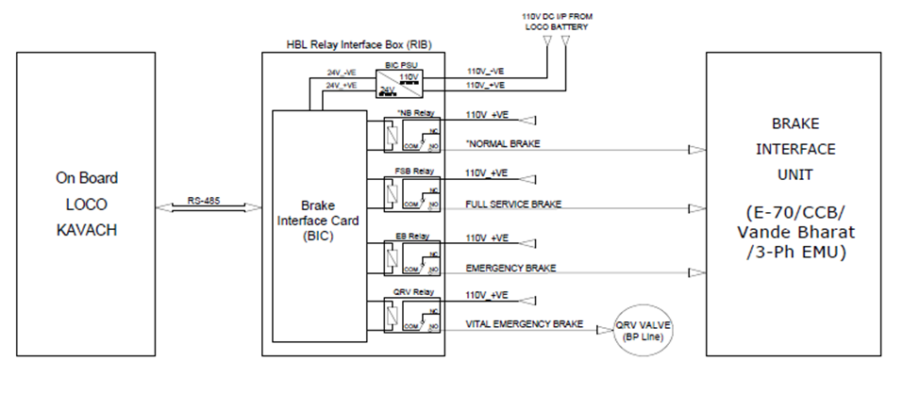

  - Brake interface card (BIC)
    - The brake interface card is the heart of the VB RIB system. This module is micro-controller based and performs the following functions.
    - The BIC card interfaces with ATP System on RS-485 communication link using optically isolated ports.

    - BIC drives the relays as per brake commands received from ATP systems.
    - For any brake application, the BIC card energies the corresponding relay which also cuts off traction. When brake is released, these outputs are withdrawn.
    - The air pressure in BP is sensed by BIC through pressure sensor.
    - BIC card Interfaces with an electromechanical counter for registering the number of times VB RIB is isolated.
    - BIC receives feedback from BP isolating cock when operated (Open / Close).

  - BIC power supply card
    - BIC power supply card that converts the loco battery supply 110V to 24 volts DC output.
    - BIC power supply card is used for powering the relays.

- COMPLIANCE WITH SAFETY REQUIREMENTS
  - Fail Safety
    - If there is loss of electric power, VB RIB automatically applies emergency brake through the VEB solenoid valve.
    - If there is a loss of communication between ATP and VB RIB, the VB RIB will automatically apply emergency brake.
    - For any brake application, VB RIB activates a control signal that is used externally in the loco system for generating traction cut off.

  - Health Monitoring
    - VB RIB electronics circuit includes power supply health monitoring and appropriate corrective actions.
    - Heart-beat monitoring of pneumatic valves:
      - Brake Interface Card in VB RIB monitors voltage and current of each energized valve / relay for every 200ms.
      - If the voltage and current values of any valve / relays cross defined tolerance limits, the corresponding valve / relays is flagged as unhealthy.
      - In such an event, ATP displays a message on the DMI that the VB RIB is unhealthy (<BRAKE Fault>) and will apply Emergency Brake.
      - The same event will be logged in ATP system.

  - Isolation

    - The VB RIB can be electrically isolated by the use of an isolation switch provided on the front panel of VB RIB.
    - The isolation switch can be changed from service to isolation mode.
    - Upon isolation, the original pneumatic circuit of the loco will function under control of the Loco Pilot.
    - VB RIB electronics will communicate to the ATP system that the VB RIB had been isolated. This causes the ATP systems to switch to an appropriate mode of operation, as per ATP system specification. VB RIB can also be isolated from the pneumatic system through operating cock installed in the BP line.
    - The isolation cock is provided with position feed back to the VB RIB brake interface card to detect the pneumatic isolation and this information is communicated by VB RIB to ATP system to change over to the appropriate mode of operation.

ATP will switch to Standby mode if the cock is not in respective position. In this condition, ATP does not provide train protection features.

- Dimensional details of VB RIB
  - Without mounting arrangement
The external dimensions of VB RIB are 479(W) x 488(H) x 192(D) mm. The figure below shows the VB RIB without the mounting arrangement.

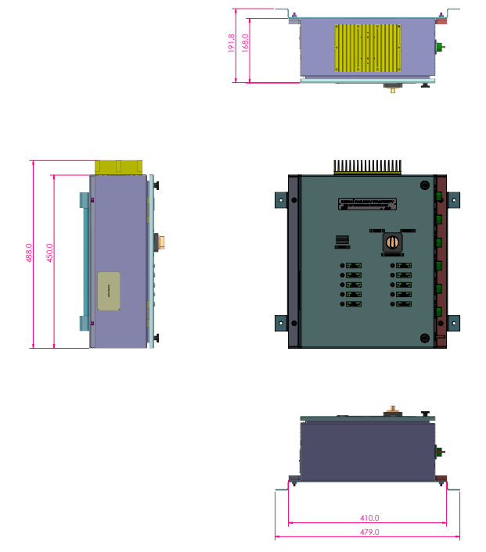

- Technical Specification Sheets
# | Item | Reference data sheet
1 | VEB Valve | 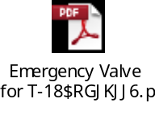
2 | Isolating cock | 
3 | Relays | 
4 | Pressure Sensors | 

- Schematic diagram of KAVACH interface with Vande Bharat braking system
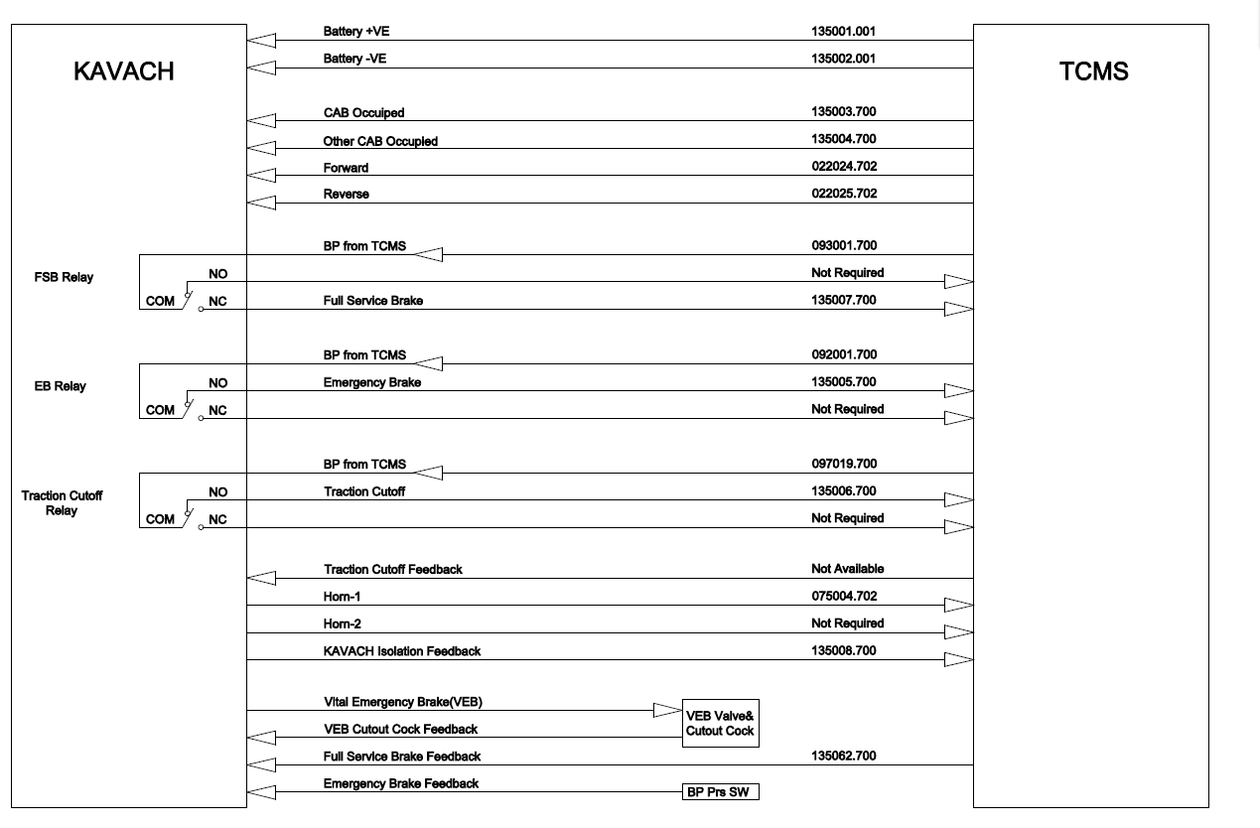
Figure 1 : Schematic diagram of KAVACH interface with Vande Bharat braking system

- Block Diagram of Relay Interface Box for Vande Bharat Locomotive.
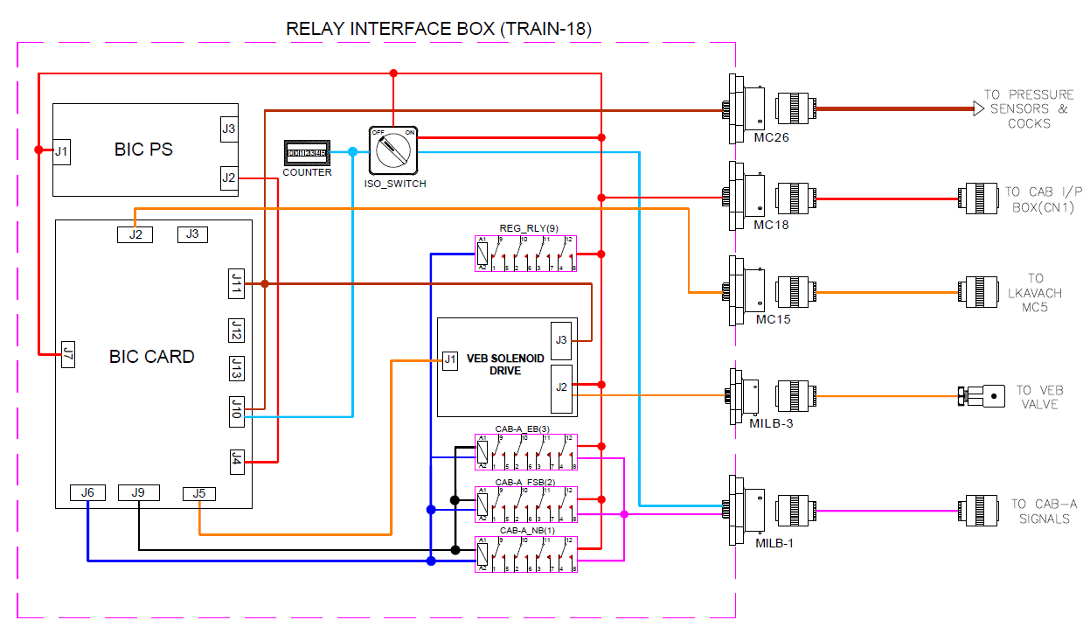
Figure 2 : Block Diagram of Relay Interface Box for Vande Bharat Locomotive

